UNIVERSITY OF PETROLEUM AND ENERGY STUDIES


Student Name: Deepanshi Shukla
Sap ID: - 590021964
Batch: B10
Course: B. Tech (CSE)
SUBJECT: python Programming lab
Experiment: 2
Submitted to:
Kamakshi Rautela

Python Programming Laboratory
Experiment 2: Conditional Statements

1.Check whether the given number is divisible by 3 and 5 both.
Code:
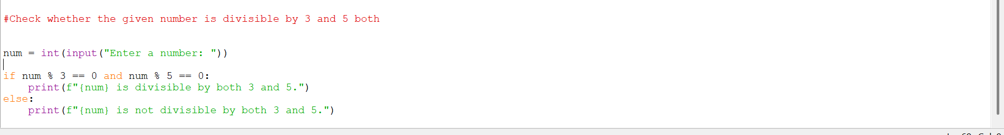
Output:
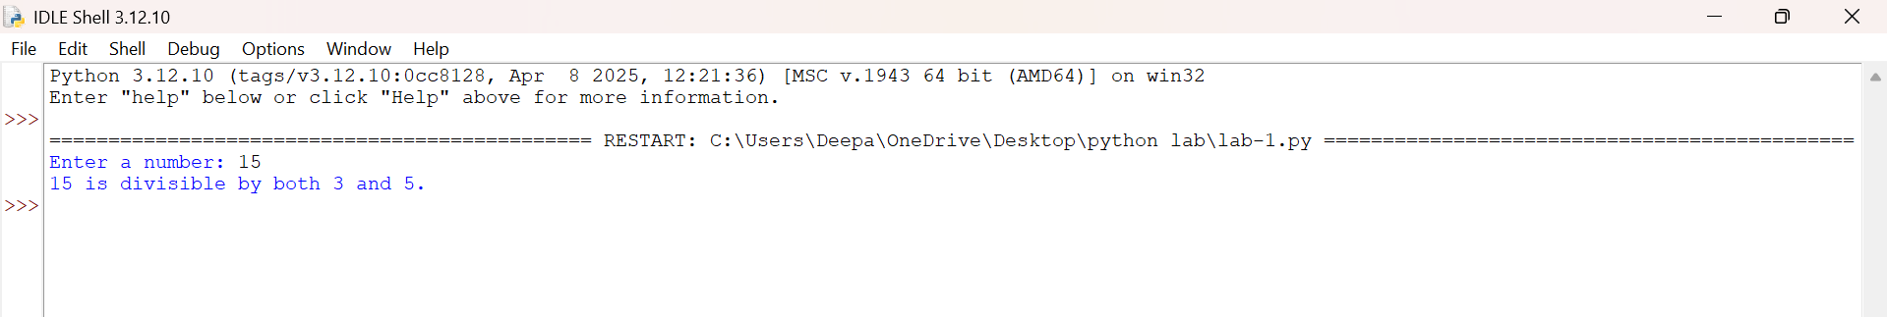
2. Check whether a given number is multiple of five or not.
Code:
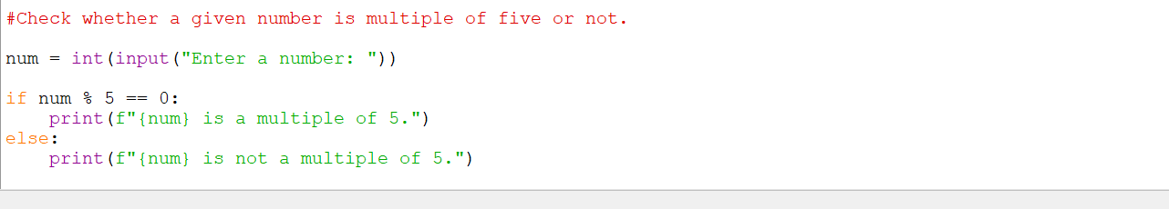
Output:
3. Find the greatest among the two numbers. If numbers are equal than print “numbers are equal”.
Code:
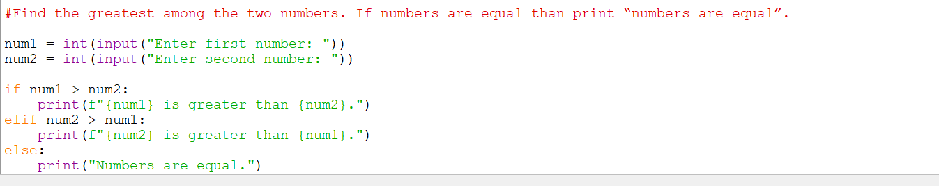
Output:
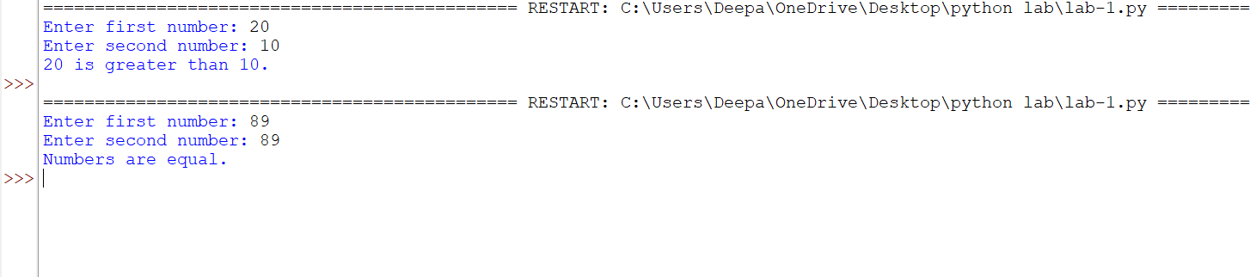
4. Find the greatest among three numbers assuming no two values are same.
Code:
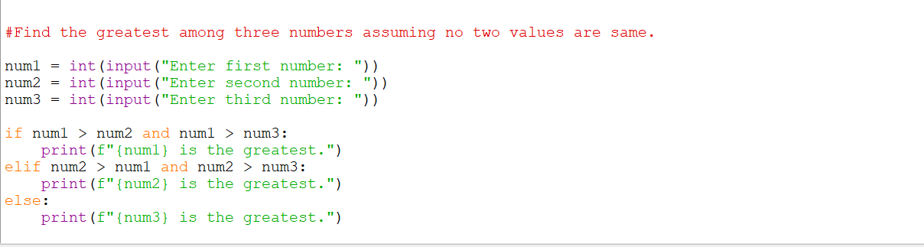
Output:
5. Check whether the quadratic equation has real roots or imaginary roots. Display the roots.
Code:
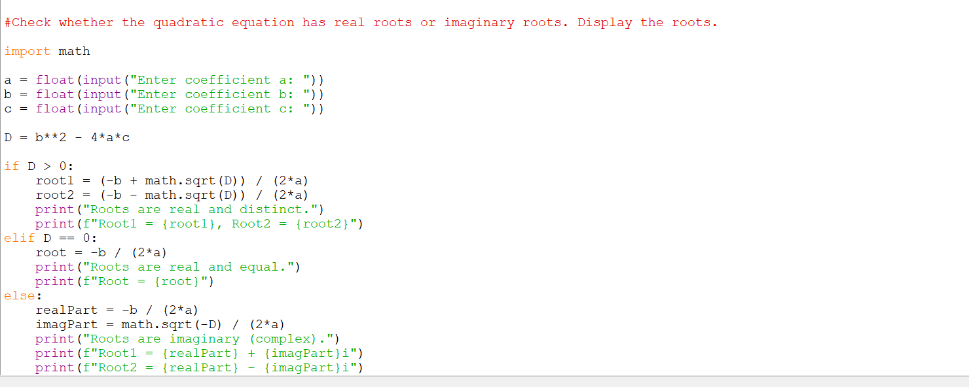
Output: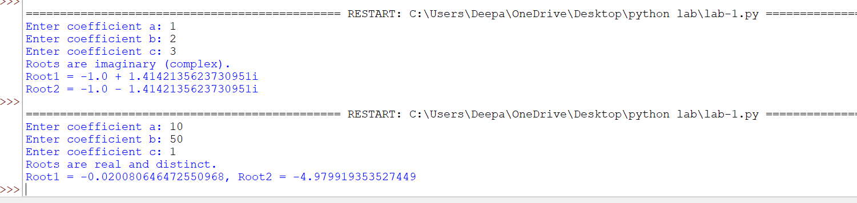
6. Find whether a given year is a leap year or not.
Code:
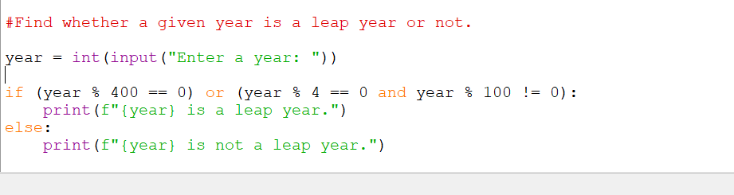
Output:
7. Write a program which takes any date as input and display next date of the calendar
e.g.
I/P: day=20 month=9 year=2005
O/P: day=21 month=9 year 2005
Code:
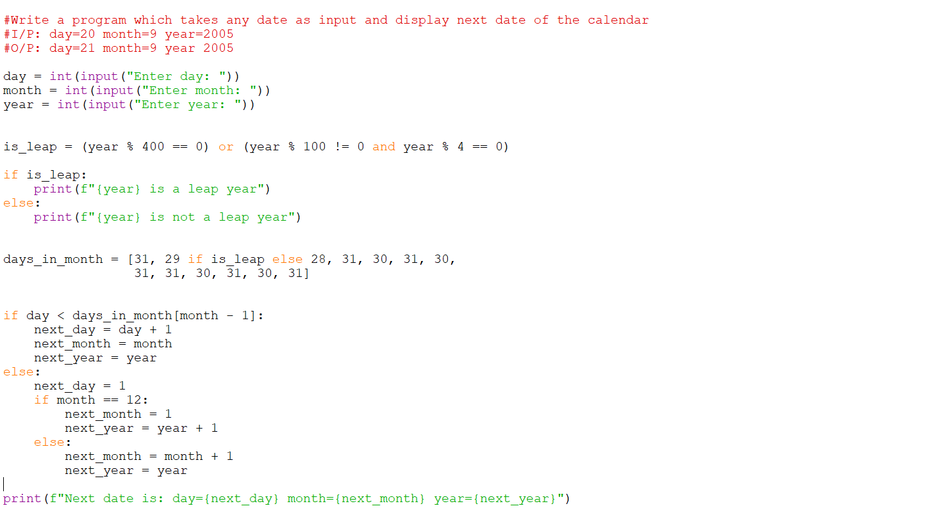
Output:
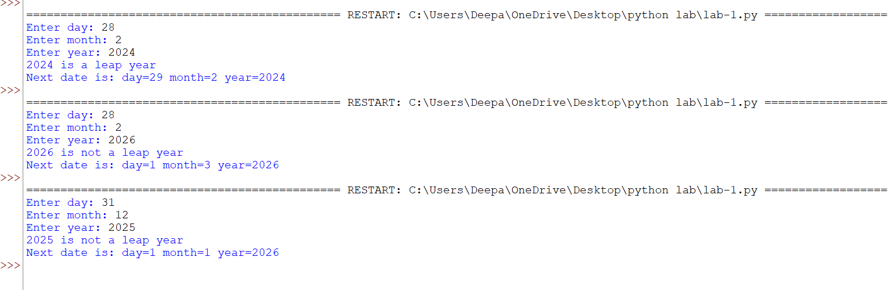

8. Print the grade sheet of a student for the given range of cgpa. Scan marks of five subjects and calculate the percentage.
CGPA=percentage/10
CGPA range:
0 to 3.4 -> F
3.5 to 5.0->C+
5.1 to 6->B
6.1 to 7-> B+
7.1 to 8-> A
8.1 to 9->A+
9.1 to 10-> O (Outstanding)
Code:
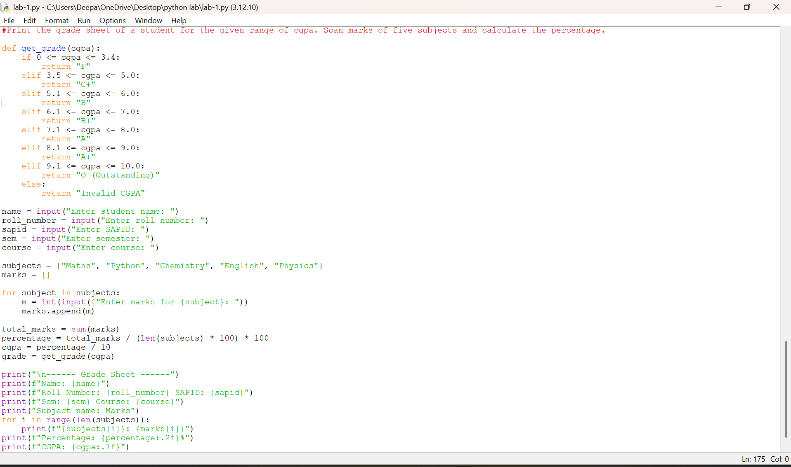
Output:
